Donna’s Announcement Page!
Last Update: 11/02/2023
- 11/2/2023
- We are a little late getting the calendar for State Technical College, please have patience it will be out soon.
- Aggregate will be 3 days, split into two parts, AT1 and AT2.
There will be a test for AT1, and a test for AT2
Two manuals.
Must take and pass both AT1 and AT2 to receive Aggregate Technician (AT) certification.
For renewal, AT1 exam will be in the AM, AT2 exam will be at noon
must past both exams to receive AT certification.
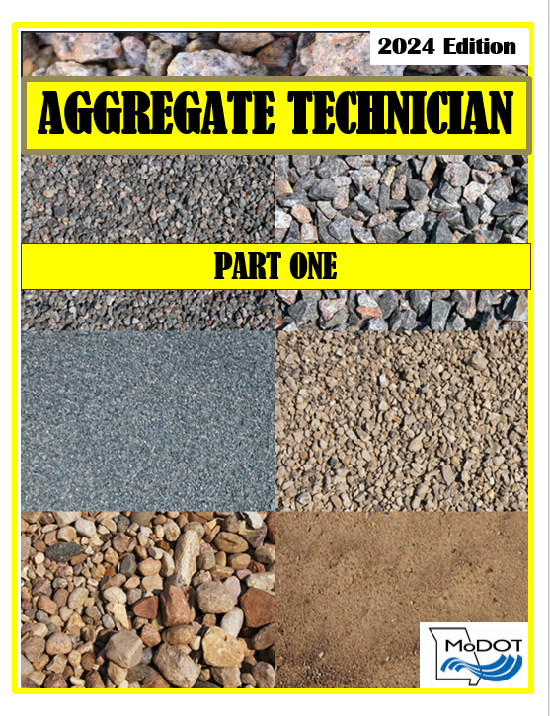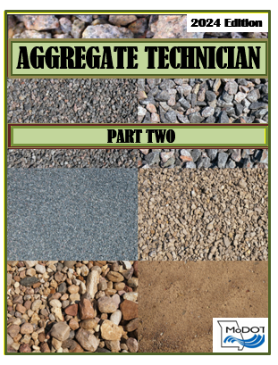
- Study Groups posted, for Aggregate Technician AT, Bituminous Technician BT, Concrete Strength CS, Concrete Field CF, and Soil Density SD. See the calendar for times and dates.
Email donna.hoeller@modot.mo.gov if you are interested

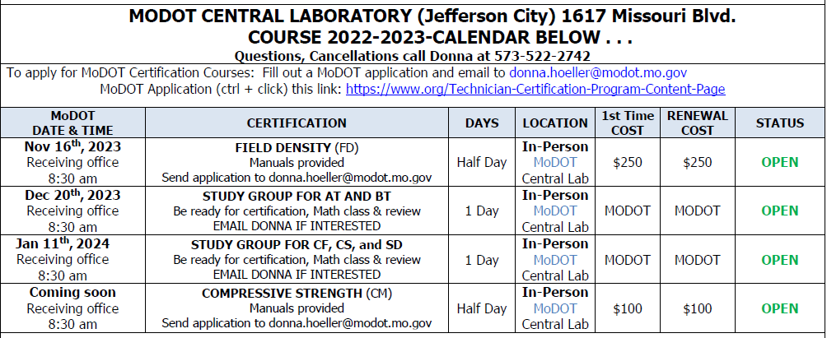

CONTACT INFORMATION:
Donna Hoeller
Technician Certification Coordinator
MoDOT Central Laboratory

P.O. Box 270

Jefferson City, MO 65102

Certification Program Coordinator: Donna.hoeller@modot.mo.gov Phone: 573-522-2742

