Structural Engineering Guidance No. 24-01

Date: May 1, 2024
Distribution: All Engineering Resources
SUBJECT: NEW LRFD SEISMIC DESIGN PROCEDURE
Contact: Darren Kemna, Suresh Patel
EPG Status: Implemented
Std. Drawing Status: NA
Effective Date: Immediately for Jobs in Preliminary Design Phase
Expiration/Duration: Indefinite

- Background and Purpose:

The AASHTO Guide Specifications for LRFD Seismic Bridge Design 1st Edition was released in 2009. Since its release MoDOT has struggled to fully implement the LRFD design philosophy due to a couple of extenuating factors:
- A design return period that was not agreeable for all states. At one point a 2500 year design event was chosen before settling on a 1000 year return period and even smaller return periods for certain applications. The current LFD seismic policy uses a 475 year return period.
- The introduction of a site class that requires geotechnical investigation before determining accurate design accelerations. This causes issues with planning cost estimates and timelines for program delivery. It is not practical, with current methods, for Geotech to produce borings before a project is scheduled and without proper bent layouts from the Bridge Division.

This SEG outlines the major changes being implemented to the EPG and provides a summary of the new LRFD Seismic Design Policy. These changes are dependent on the release of the 2023 interims to the AASHTO Guide Specifications for LRFD Seismic Bridge Design which includes a new risk-targeted design spectra and the elimination of return periods for seismic bridge design. These changes maintain the practical design philosophy that was introduced previously into the LFD design procedure (i.e., major routes and 1st and 2nd priority earthquake routes are considered critical for post-earthquake recovery efforts).

- Preliminary Seismic Design Map

For LFD design an aerial map was used that shows the boundaries between the different seismic zones. This map cannot be duplicated for LRFD design because local site class affects the final design category classification. Yet, in order to develop a workflow that is similar to our current workflow, which requires a preliminary cost estimate and bridge design schedule estimate prior to the geotechnical investigation, a map is required with some conservative estimates for the seismic design category.
The map below is developed assuming a site class D is present throughout the state. In Missouri, the vast majority of bridges are founded in soils with site class C or D. In the risk-targeted design spectra that were developed for the 2023 interims, site class D represents the worst case scenario for design accelerations and SDC classification. Site class E results in lower accelerations and Site Class F is removed entirely. Prior to the 2023 interims, Site Class E resulted in higher accelerations than Site Class D.
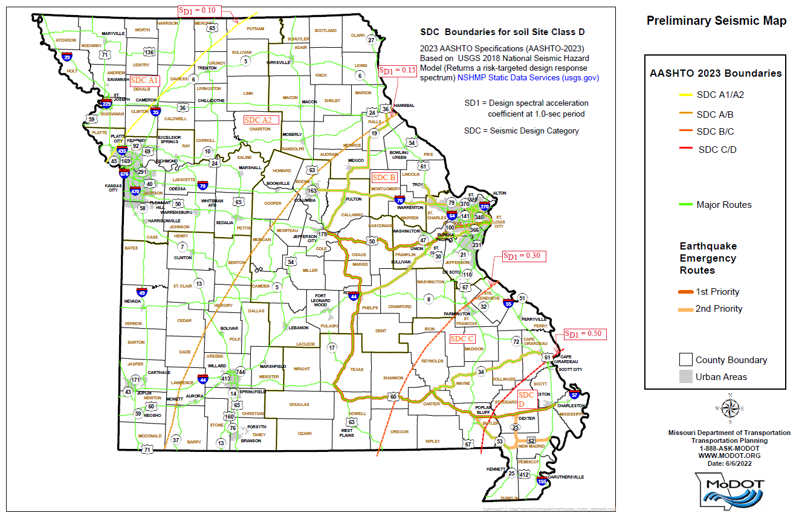
Figure 1 – Preliminary Seismic Design Map. Seismic regions based on Site Class D and AASHTO Guide Specifications for LRFD Seismic Bridge Design (SGS) 2023 (Risk-targeted design spectra return from preliminary USGS 2018 National seismic hazard model, NSHMP Static Data Services (usgs.gov)). Bold green lines are major routes. Orange highlighted roads are 1st or 2nd priority earthquake emergency routes.

The map is broken down into five regions (A1, A2, B, C & D) based on the SDC classification. SDC A1 and A2 are commonly grouped together and referred to as SDC A. Unlike the LFD seismic map only the 1st and 2nd priority earthquake emergency routes are shown. Third and fourth priority routes are not shown for clarity. No changes have been made to the priority routes with this update. These routes are designed to get personnel from Jefferson City to the southeastern portions of the state.
- LRFD Seismic Design Workflow for New Bridges

A Bridge Seismic Planning Flowchart has been developed to aid staff with the new workflow. The typical PS&E submittal deadline is 13 months. The PS&E submittal deadline is only increased to 24 months for bridges that require a complete seismic design (and railroad crossings). In addition to the Bridge Seismic Planning Flowchart a Bridge Seismic Design Flowchart covers in more specificity the level of design or details required for culverts, walls and bridges. The Request for Final Soundings for Structures Form has also been updated to coincide with the processes outlined in the flowcharts.

A list of the major factors that affect the level of seismic design or details is given below:

- For preliminary planning and cost estimates, the SDC values will be assumed as shown on the preliminary seismic map.
- For bridges located in SDC A on the map the preliminary SDC will also be used as the final SDC. Site class verification will not be performed, A_{s} will not be reported on the plans and S_{D1} will be reported as “< 0.15”.
- For bridges located in SDC B, C or D on the map the Geotechnical section, in their normal workflow, will determine a site class and report a final SDC, S_{D1} and A_{s} in the Foundation Investigation Geotechnical Report (FIGR). Note that the final SDC may get downgraded to a lower level (i.e., C to B) in comparison to the map.
- If a bridge site gets downgraded to SDC A2 after Geotech analysis and is located on a 1st or 2nd priority route the bridge will receive seismic details as required for SDC B. Similarly, if the downgraded bridge is not located in a 1st and 2nd priority route it will not require seismic details. If a bridge site gets downgraded to SDC A1 it will not require seismic details regardless of location.
- If a bridge receives a final classification of SDC C or D and is located on a major route or 1st or 2nd priority route the Geotechnical section will perform a liquefaction assessment.
- All bridges receiving a final SDC B will require seismic details for the intermediate bents, and at a minimum, seismic details for the abutments. If the bridge is located on a major route or a 1st or 2nd priority route the abutments will be designed for the mass inertial forces in accordance with SEG 24-02.
- All bridges receiving a final SDC C or D and located on a major route or 1st or 2nd priority route will receive a complete seismic analysis. If a bridge on a major route or 1st or 2nd priority route gets downgraded to SDC B, then see previous bullet and there may be a windfall in the project schedule and cost estimate for bridge design and details.
- All bridges receiving a final SDC C or D and not located on a major or 1st or 2nd priority route will only receive seismic details based on the final SDC classification.
- The design response spectral acceleration coefficient at a period of zero seconds, A_{s}, shall not be taken to be greater than 0.75. With the new risk-tageted design spectra the A_{s} values when approaching the New Madrid fault become very large (greater than 1.0) and would lead to impractical designs. When the states were presented the ballot item for vote, they were presented with response spectra for large cities across the country (including St. Louis). Based on this data the largest A_{s} value for all cities affected was approximately 0.75 so that is the basis for this practical limit. When a complete seismic analysis is performed A_{s} should be limited to 0.75, but the rest of the response spectra should not be modified.

The level of seismic implementation will be reported on the plans using one of the five classifications given below:
- Nonseismic: For SDC A only. Superstructure anchorage and beam seat checks only.
- Seismic Details: Additional seismic details are required beyond those required for Nonseismic.
- Abutment Seismic Design: For single span bridges only. Abutments are designed for mass inertial forces.
- Seismic Details plus Abutment Seismic Design: Seismic details required for intermediate bents. Abutments are designed for mass inertial forces.
- Complete Seismic Analysis: Seismic design force concepts are included as outlined in EPG 751.9.1.3 and modified for LRFD where required.

- Abutment Seismic Design

Abutment Seismic Design as constituted in SEG 24-02 is a completely new concept from previous practice. Where indicated the abutments are designed using tributary mass inertial forces without the need for seismic modelling. The concept is adapted from the SGS requirement for single span bridges and expanded to multi-span bridges in SDC B on important routes. Designing the abutment to behave elastically for mass inertial forces will help to limit the demand on the intermediate bents which are still required to receive seismic details. The wing design is most likely impacted and can include extra reinforcing, thicker walls, larger wing braces or an additional intermediate wing. The heavier the superstructure the more likely the impact to overral cost of the structure. See SEG 24-02 for more details.

- MSE Wallls – Additional Information

While not the focus of this SEG, the update to the seismic policy was coordinated with the LRFD updates for MSE walls. Besides LRFD updates the classification of MSE wall systems has been updated to better reflect industry terminology.

- Geotechnical Limitations and Research

Per SGS 3.5, if liquefaction induced lateral spreading or slope failure can occur, the bridge should be designed for SDC D. MoDOT has ongoing research to determine the appropriate methods for evaluating lateral spreading. Currently, the cost for evaluating and potentially mitigating lateral spreading is substantial and the impacts on bridge design are not well known. Until specific policy is implemented from the ongoing research, the current policy is to ignore liquefaction induced lateral spreading and slope failure in bridge design. Where liquefaction is a concern the engineer shall make appropriate assumptions about unbraced lengths for piles and columns in accordance with established practice in EPG 751.9.

Accurate site class definitions are based on time-average shear wave velocity measurements in the upper 100 feet of a geologic profile. MoDOT currently does not have the equipment to take direct shear wave velocity measurements. Current methods for determining shear wave velocities are based off correlations from SPT or CPT data which result in an uncertainty of plus or minus 30 percent. Due to the inaccuracies of current methods, MoDOT has ongoing research to update and refine sesmic site investigation and analysis procedures. In the meantime, due to the inaccuracy of current methods, it is likely that the vast majority of site class investigations will return a Site Class D classification.

- Bridge Seismic Retrofit Flowchart

For modifications to existing structures, states have the option of using the LRFD BDS and SGS specification or the specifications that were used for the original design. Since rehab work typically does not include a foundations investigation, the new procedure allows the designer to use the SPC or SDC reported on the existing plans or the SDC from the Preliminary Seismic Design Map. A table is provided for equating SDC categories with the hazard levels provided in the Seismic Retrofit Manual for Highway Structures. If SPC is reported on the existing plans, the level reported may be assumed equal to the SDC letter designation in determining the equivalent hazard level (e.g, SPC C = SDC C = Hazard Level III).

