Structural Engineering Guidance No. 15-04

Date: November 19, 2015

Distribution: Internal Bridge Division Grades 17 and Above

SUBJECT: SUPPLEMENT TO SEG 15-03 PRE-RELEASE ON STRIP SEAL AND PREFORMED

SILICONE/EPDM SEAL EXPANSION JOINT SYSTEMS USING NEW DESIGN

CRITERIA

Contact: Gregory Sanders/Suresh Patel

EPG Status: TBD

Std. Drawing Status: TBD

Effective Date: NA

Expiration/Duration: Under Review By Grades 17 and Above Until Further Notice

Background and Purpose:

SEG 15-03 is being distributed as a “Pre-Release” Guidance internally to Bridge Division. SEG 15-03 intends to update EPG articles on sealed joint systems (SJS) specifically strip seals and preformed silicone or EPDM joint seals by introducing more stringent new design criteria which includes specific manufacturers’ design checks such as installation and skew effects (racking) criteria. Its purpose is to extend the service life of these joint systems through a more thorough design routine. (*Note: SJS refers to strip and preformed silicone/EPDM expansion joint systems. Preformed compression joint seal system is not included in this discussion but may be in a future guidance.*)

SEG 15-04 is a supplemental guidance to SEG 15-03 and takes a different trajectory in addressing the issue of extending service life of SJSs at MoDOT from having evaluated our current design method and re-examined sealed joint systems policy and practice specific to strip seals and preformed seal systems.

Performances of SJSs are not critical but there is concern based on comments from staff such as that there are some premature pullouts of strip seals at less than full contraction, some premature failures of the seal itself and the fact that installation openings are especially critical and should be monitored closely which may not be the case during construction. It was also learned that the average life of a MoDOT strip seal expansion joint system is 15 years which is less than the commercially advertised service life of a proprietary strip seal at 20-25 years. (*Bridge Division has used 7-10 years as a service life of these seal systems at one time but it may be more like 10-15 years now.*)

This guidance introduces *items of interest* that could improve the state of joint seal system installs, re-installs, maintenance, and service life or have no negative affect at all. These *items of interest* are recommendations based on AASHTO LRFD Bridge Design Specifications, NCHRP 319 and practice at other State DOTs.

It is being released to Grades 17 and above for their consideration and input. Implementation could mean adoption into practice of all, some or none of the following *items of interest*.

References for SEG 15-03 and SEG 15-04:

NCHRP Synthesis 319 Bridge Deck Joint Performance

Emails and discussions with Pat Martens, former Supervising Bridge Inspection Engineer

AASHTO LRFD Bridge Design Specifications

“*Joint Sealing Systems in Missouri**”,* MoDOT Bridge Div. /Bridge Maintenance, Pat Martens, 2011

Comments in Email on SJSs, Pat Martens, Supervising Bridge Inspection Engineer, 2014

Manufacturers, DS Brown, Watson-Bowman-Acme and RJ Watson

Other State DOTs design manuals, examples, standard drawings

EXAMINING Items of Interest:

1. Maximum Possible Expansion Lengths:

Steel and concrete bridge maximum possible expansion lengths using SEG 15-03 (*new design criteria*) may be greater than expansion lengths possible using current practice for squared structures and may be less for skewed structures. Because the new design criteria are a more thorough design check and more conservative (*but more accurate*) considering skewed bridges, this seems reasonable. Maximum possible expansion lengths are not given in the EPG now nor computed and given in the Pre-Release using the new design criteria.

1. (A) Including Proprietary Names of Accepted Sealed Joint Systems on Plans:

It is proposed to report all SJS manufacturers and models accepted by design on the bridge plans. Accepted SJS models match bridge expansion conditions with the manufacturers’ design information. All three manufacturers have been contacted and asked about this practice and all agreed that it was acceptable to report specifically their products on the plans.

There are only two manufacturers that produce strip seal expansion joint system products: DS Brown and Watson-Bowman-Acme. There are three manufacturers that produce preformed silicone or EPDM system products: DS Brown, Watson-Bowman-Acme and RJ Watson. (*RJ Watson ceased producing strip seal expansion joint systems.*)

Specific manufacturer’s design information will be included in the EPG with design examples.

(B) Current Practice of Showing Seal Width:

Current practice is to show an accepted joint seal width on the plans for a strip seal. The same is the case for preformed silicone/EPDM seals when they have been used.

There should be a better way to indicate an SJS required. Manufacturers don’t report seal width in their published design information.

Strip seals are sized by manufacturer based on total movement and full closure. Showing a fully extended strip may give the wrong impression since we do not ever want a seal fully extended. We use load factors and minimum openings at full contraction that a manufacturer much less a contractor may not know to make the jump from a shown joint seal width to a system model to use on the bridge.

**Recommend:** Eliminate identifying SJSs by joint seal width on plans. Specify each manufacturer and model that is accepted by design check on the plans.

1. Including Accepted Installation Temperature Range Table on Plans:

Being more particular about installation temperatures and gaps makes sense in order to lower the risk of joint seal failure and get better insurance for a long service life. Providing them in a table on the plans is good for MoDOT construction inspectors and it makes it impossible to not consider. Secondarily, with this predictive model, we may be able to take advantage of the load factor and realize the true benefit as an unused safety factor. This could mean less incidence of strip seal failure. Using a 1.0 load factor for new bridge and existing bridge installation openings will help meet manufacturer’s installation requirements.

Recall that no information about installation criteria is shown on the bridge plans. Right now, a note is used on the plans instructing contractors (and inspectors) to adjust the gap based on every10º temperature difference. A note can be easily missed, ignored, glossed over as unimportant.

**Recommend:** Use table on plans showing accepted temperature range for installation. Limit installation to these accepted temperatures.

1. (A) Tooling, Resealing and Retrofit Recommendations:

Investigate repairing joint seals with new tooling requirements and requisition pneumatic, hand tools and practices for extracting old seals and inserting new seals. This way, the strip seal system can be perpetuated utilizing existing, in-place armor without resorting to filling “between” the armor with other less durable or short term joint types. This would depend on the remaining life of the armor, and the material cost for just a seal is not that expensive.

Long term maintenance strip seal replacement: Strip seals are not replaced (reusing armor) on letting jobs typically. If the armor is in good condition and the seal is removable, it is recommended to re-seal in this situation. Or, if seal is nearing design life but still good and armor is still good, it is suggested to replace seal before seal fails. The unique shape and the resistance with which it takes to install a strip seal into the preformed lugs (or ears) of the armor is testament to the resistance with which these seals can survive long term in properly designed installations to resist pullout and racking. Seals that go in more easily typically have less service life, case in point, adhesive seals like silicone joint seals that when inadequately installed, fail. They are no longer permitted on contract bridge jobs.

“Running” the seals out past the edge of deck like new strip seals on new decks is not possible with reseals. New seals can only be run out when the barrier rail is absent (or before new placement). In this case it may be better to add an adhesive seal up in between the barrier ends to act like a bathtub rather than run the reseal less than optimum and just drain on bent cap ends. Another option may be to add a shoulder drain troughs (fabric deflector shield) under and bolted to deck to deflect drainage out and away from direct impact on bent caps.

The Barrier Problem:

Extending new seals (”running” them out to beyond the edge of the slab) on new bridge construction is made possible because seal is installed in deck before barrier is constructed. Because armor on new and replacement bridge installations is extended to the edges of the deck, and because no allowance is made for blocking out the barrier to allow seal installation, a seal re-installation (seal replacement) through barrier in deck is impossible without removing the barrier. Moving forward with this would require a special detail for re-installing a seal like:

*Do-nothing option and just don’t seal deck between barrier ends on deck.*

*Use a pourable silicone seal underlapped/overlapped to a strip seal at barrier ends.*

*Use a preformed silicone/EPDM seal.*

*Use a trough under deck between ends of deck; fabric sheet bolted to underside of deck.*

*Replace barrier sections to replace armor and seal.*

Running the Seals Out:

Is this practice questionable? AASHTO requires/recommends running strip seals out past the edge of the deck. It requires/recommends preformed compression joint seals to be run up into the barrier. Bridge Division prefers both seals to be run out past the edge of the deck. Is there an advantage to not running the seals out and letting the drain system do the work?

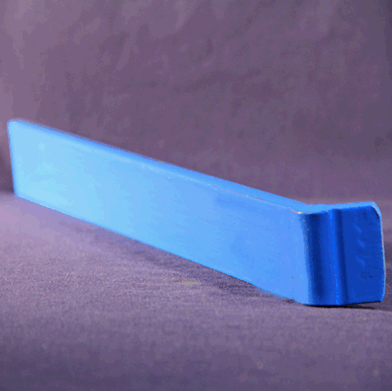

*Pictured: Hand Tool (Source: DS Brown)*

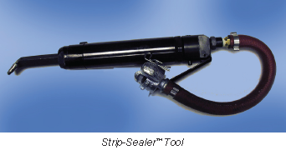

*Pictured: Pneumatic Tool, $100 (Source: DS Brown)*

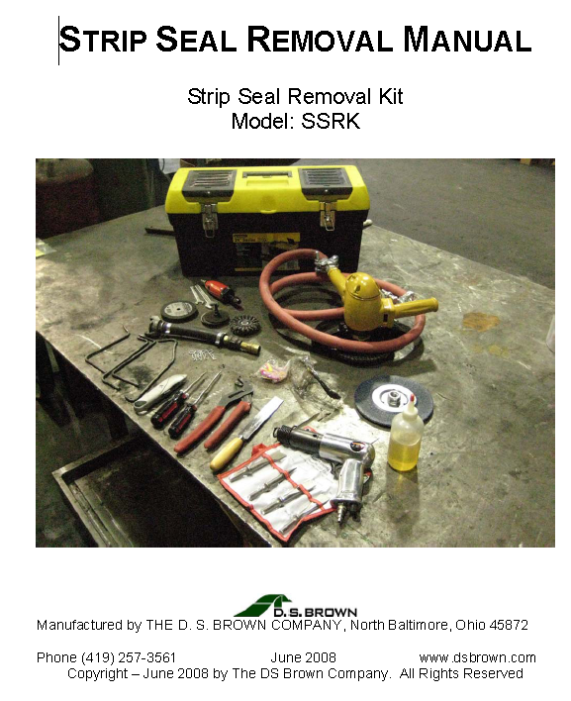

*Pictured: Strip Seal Removal Kit (Source: DS Brown)*

(B) Bridge Rehabilitation Form Revision to Include Strip Seal Replacement:

Revise to include reinstallation inspection. Recommend to add option to re-install a strip seal or install a preformed silicone/EPDM seal. Inspect cavities if possible for rust and feasibility to replace seal only. Option to be shown may be to require a contract re-install or maintenance re-install. Also, if a silicone joint seal is accepted, then a maintenance install should be shown as a possible request.

Something should be added to the rehabilitation checklist.  What if we amended the existing check box columns for "Repair" and "Replace" to "Repair Seal" and "Replace Seal" and added two more columns for "Repair System" and "Replace System"?  This should tell us if the seal is bad (replace seal is checked); but, if the armor is good (replace system is not checked) or if the whole thing needs to be replaced (replace system is checked).  It won't, however, give you enough information to know if the armor is good enough to receive another type of seal (e.g., a preformed silicone or EPDM exp. jt. seal instead of a strip seal); maybe this type of review can be added or made known to inspectors.

**Recommend:** Revise to suit.  
  


*Figure: Section of Rehab Form Related to Expansion Devices*

1. Policy on Armored Joints:

What is the policy on using armored joints on sample categories of new bridge construction, redeckings, rehabilitations, maintenance repair, and emergency repairs? This is not stated in the EPG. Categorized by construction and rehabilitation type and who performs the work, some suggestions are:

New bridge construction = use armor

Older deck = none; just get by. (*Could consider open joints with troughs*.)

Redeck = use armor

Replace expansion system = use armor

Reseal = clean and re-use exist armor

Overlays = remove armor, add nosing, seal

Contract letting job = use armor

Maintenance job = option to clean armor and reseal, re-armor and seal, or remove armor and seal or use pourable joint, silicone joint.

**Recommend:** Use armored joints on new bridge construction, new deck construction, or any bridge with high ADT; Armored joints is not necessary if concrete deck is not being replaced.

1. Snowplow Resistance Detail:

Using tabs *(“ribs” or “bars”*) on armor may help to reduce impact to seal and armor. Recessing will help with this also.

Avoid snowplow angles. Anything between 30-35 degrees would be a problem. Use ribs and recess, although adding a rib detail while used infrequently does require adding another detail. A rib is essentially bridging the gap so that a snowplow blade rides the “rib” and avoids impacting the joint squarely when impact force would be greatest.

**Recommend:** Use metal tabs when skew matches snow blade skew and if detail can be efficient. Follow AASHTO LRFD 14.5.3.3. Moving forward would mean finding an appropriate SJS detail to use for special skewed orientations most susceptible to snowplow damage. (*Must not prevent seal removal and replacement.*)

1. Recessing:

Recessed joints are used to prevent or lower the risk of punctured seals and armor destruction due to traffic and snowplows. ¼” below grade will eliminate possibility of “high” joints, or joints placed higher than deck, and will help with joints that match a snowplow blade skew.

**Recommend:** Recess joints. Follow AASHTO LRFD 14.5.3.3.

1. Identifying Gap:

Setting gap on new and existing bridges policy, use 2” for new and existing or use existing gap as original plans. Not clear in EPG. Never was. Gap at 60 degrees will be shown on the plans based on design for new bridge and armor setting existing bridge and existing gap for other case.

**Recommend:** Should be based on design. Can vary by job; 2” preferred just because it’s easy to use.

1. Splicing:

Splicing of joint seal should not be allowed and if specially allowed then should be vulcanized according to AASHTO. Other sources state that splicing should not be allowed period. It introduces a weakness and for joint seals that experience transverse movement this can be cyclically deteriorating over time. Manufacturers don’t permit splicing without owner’s approval. AASHTO LRFD does not recommend seal splicing. Steel armor splicing is permitted with provisions. We recommend following AASHTO LRFD 14.5.5.3, 14.5.6.4, 14.5.6.7 and incorporating appropriate plan notes. Note to designers in standard drawing guidance to adhere to AASHTO LRFD and that field splices provided for staged construction shall be located with respect to other construction joints to provide sufficient room to make splice connections.

**Recommend:** No splicing. See engineer if splicing is required. All splices must be vulcanized. Follow AASHTO LRFD.

1. Proof Testing, Water Tightness Criteria and Incorrect Installs:

Testing for water tightness is recommended in NCHRP 319 Bridge Deck Joint Performance and some states require this. It can be as simple as pouring water over a sealed joint and checking for leaks underneath *before acceptance*. Why wait until it rains. Good insurance to begin a long service life.

If it does not pass, joint should be re-sealed. For strip seal, a typical failure means that not enough lubricant/sealer may have been applied or the lug is not fully inserted into the steel armor cavity. Worst case for any type strip seal or preformed seal is that the seal is broke/split/torn and *before final construction acceptance is when to determine this*.

Inspector’s notes: Closer inspection for strip seals to make sure they are watertight and installed properly in lugs from the beginning and in the right position to deflect downward when compressed.

Could be as simple as checking it after a first hard rain. Problem is if it fails.

**Recommend:** Testing by means that are efficient, practical and sufficient to show watertightness and correct install. No need for expensive test.

1. Incorrect Installs (according to NCHRP 319):

A State DOT had reported that strip seals had been installed upside down in the past and since have required that the manufacture mark the upside appropriately to identify the correct install position. Also, it was reported that joint seal lugs were not always installed properly ranging from lugs only partially installed in armor to lugs not installed at all on one side to lugs not installed in armor at all on both sides. The point is that mistakes do happen which can be averted if foreseen.

These errors highlight that while mistakes happen, they can be foreseen and corrected. It also portends that with two different types of preformed seals, where strip seals and preformed silicones bend oppositely when installed and when working (strips seals bend down, preformed silicones bend up), potential exists for stupidity. Manufacturers of both systems profess that both types, bend down and bend up, drain fluid and debris more efficiently. Go figure.

A foreseeable problem in our case may that the orientation of the joint seals for the strip seal and the preformed silicone/EPDM joint seal are oppositely positioned in the joint opening based on connection requirements and self-cleaning operation of the seal. While the strip seal is shaped to function as a “V” shape, the preformed joint seal is shaped to function as an inverted “**˄**”, or roof top.

**Recommend:** It may be a good idea to point out on plans for each joint seal that “The orientation of the joint seal in opening is as shown.”

1. Plan Reporting:
2. Plan revision proposed:

“Hand packing of concrete under joint armor” at Joints seems to be the recommendation of AASHTO LRFD C14.5.3.5. We require the following “Concrete shall be forced under and around steel armor and anchors”. Is this the same as requiring “Proper consolidation of the concrete shall be achieved by localized internal vibration”? Are these the same level of labor?

1. Placing restricted range of temperature on plans for installation.
2. Placing a table of temperatures and corresponding gaps normal to joint in 10 degree increments for installation temperature range on plans.
3. Specifying exact name and manufacturer of as many seal systems as possible required *by MoDOT design* for preformed silicone/EPDM and strip seal. We actually design the strip seals and preformed seals, but intentionally include vague details about which seal we want on the plans. We give a width of seal on the plans determined by design. The problem is that only one of the three manufacturers use a width to specify their product.
4. Protect galvanized edge rail assemblies during screeding operations per the manufacturer’s recommendations.
5. Provide temporary blocking material in the edge rail cavities to prevent concrete intrusion during deck pour and finishing.
6. Install elastomeric seal after completion of deck casting. Install according to manufacturer’s recommendation.
7. Recess joint (must account for planning of deck). 0”, minus ¼” after planning OR 3/8” +/- 1/16” below top surface before deck planning.
8. Ambient air temperature is nowhere reported on the plans. It is always discussed as to what it is. AASHTO LRFD 14.5.5.1 defines it for us. Ambient air temperature definition should be on plans: “The actual air temperature averaged over the 24-hour period immediately preceding the setting event.”
9. When a field splice is required, “permanent seals shall be placed after joint installation is complete. Only continuous seals shall be used.” AASHTO 14.5.5.3.
10. Future:

Upgrade preformed compression joint seal systems for same design and plan reporting treatment as recommended for strip seals and preformed silicone/EPDM seal systems, and consider the following guidance:

Consider:

Install compression joint seals in colder weather; since most construction work is in the summer, the compression seals are typically installed at the worst time of year.  When the bridge gets cold it puts a lot of tension on the seals.  If you inspect the seals in the summer they frequently look tight, but leak profusely because the bond was broke over the winter. Pat Martens recently wrote on this in a summary to the Development Section. Compression joint seals are recommended to be installed when bridge is contracted. If done the other way then the seals can wear out prematurely and are more difficult to install.

Consider:

Use temperature criteria for preform compression joint seals installations. Colder designs and installs may prove longer lasting. Compressing joint seals for installation into small gaps has been proven detrimental to long term service by allowing joint seal to malfunction and colder temperatures due to memory problems and problems with compressing seals and gluing.

1. Lucky 14:



Suggestions and recommendations concerning this guidance or procedure should be directed to the Development Section for review and updating the Engineering Policy Guide.